Introduction/Background
Within the rhetoric surrounding long-term care homes, mention of inadequate staffing levels and quality of care are discussed, but little is mentioned surrounding racism within long-term care. Racism can prevail in elements such as the western focused art on the walls, stereotypical therapeutic recreation programs, and only Catholicism centered religious spaces which all breed racism within long-term care homes. Homes are known for little effort in welcoming anyone beyond white-middle class older adults, and persons of colour are underrepresented in the populations receiving care in long-term care homes (Nichols, 2020). Apart from residents, even staff members of diverse cultures are not present which leads to gaps in care due to a lack of understanding of culturally appropriate care (Nichols, 2020). When long-term care homes are not supportive and respective of cultures it leads to isolation of residents, healthcare consequences, spiritual isolation, distress, malnourishment, and alienation (Ontario Centres for Learning, Research and Innovation in Long-Term Care, 2017). Residents feel unable to speak the language of their culture nor are they provided food that is prevalent in their culture, or services and religious ceremonies that are centered around their beliefs (Ontario Centres for Learning, Research and Innovation in Long-Term Care, 2017).
Strategies pertaining to anti-racism are not a one size fits all approach. Well-developed frameworks laying out the steps needed to diversify long-term care and organizations need to be developed. In this jurisdictional scan I analyze a culturally appropriate organization in Australia and the six-stage model of change in British Columbia (BC).

Methods
This jurisdictional scan focuses on the analysis of the literature on current practices to address systemic racism in long-term care, and how other governments are working to address the issue. Australia and British Columbia were both locations where resources have been generated to improve the issue or provide a framework that can be translated to other regions to combat racism within long-term care homes.
When determining which cases to include, I examined many with key inclusion criteria. The first criteria were that a framework or resource would be ideal for implementation in other regions. In Australia they developed a service to ensure that culturally appropriate services are provided to Aboriginal peoples, an impactful service that could be established within Canada, even Ontario. BC also provided a framework that assist in the development and framing of issues and how to go about changing them. For these reasons, Australia and BC were included as case studies.
The second criterion was that the case study sought to address racism and aimed to address the issues. In Australia, the central focus on the Aboriginal Community Controlled Health Service (ACCHS) was to provide a resource for Aboriginals to seek care regarding health needs, but also provided other services to address other social determinants of health. Additionally, BC’s model although not explicit, provides a step-by-step process in which racism can be addressed. For these reasons, Australia and BC were chosen as they each set to address systemic racism through cultural organizations and change frameworks.

Case Studies

Australia - Aboriginal Community Controlled Health Services (ACCHS)

Established in 1971, and with a primary focus on prevention and early intervention, the ACCHS works to build healthier Aboriginal communities (Aboriginal Health & Medical Research Council, 2015). ACCHS is a form of primary health care service operated by Aboriginal communities within a local area (Panaretto et al., 2014). They provide holistic and culturally appropriate care to the specific community, and work with the patient to support them through various social factors including racism (Pearson et al., 2020). The ACCHS is a team-based model providing culturally appropriate patient centered care (Panaretto et al., 2014). Ultimately, the ACCHS utilizes advocacy, community collaborations, community empowerment, and more to address and improve the communities in which they operate (Pearson et al., 2020). Rather than a traditional way of dealing with health needs via clinics, the ACCHS offers a community space where Indigenous peoples can address their needs (Pearson et al., 2020). ACCHS also work to address elements other than health needs such as providing programs to increase education and employment opportunities (Pearson et al., 2020; Panaretto et al., 2014).
The workforce of this service includes specific Aboriginal Health Workers, who also work with non-Aboriginal health care providers to understand the level of care needed and how to communicate better with patients (Aboriginal Health & Medical Research Council, 2015). Additionally, the ACCHS provides opportunities to its employees to engage in cultural mentoring to non-Aboriginal health professionals or health promotion roles (Aboriginal Health & Medical Research Council, 2015).
To ensure the proper functioning and success of the service, local Aboriginal communities elect a board of directors to oversee the service and ensure accountability (Aboriginal Health & Medical Research Council, 2015). Each community service differs in its amount of funding, size, infrastructure, workforce and more (Aboriginal Health & Medical Research Council, 2015). Additionally, the types of services offered are all dependent upon the community the service is operated within, emphasizing again, community focused, culturally appropriate care (Aboriginal Health & Medical Research Council, 2015).

British Columbia – Six Stages of Change model
The Affiliation of Multicultural Societies and Service Agencies of British Columbia has developed, as part of their long-term anti-racist strategy, a model of change that aims to address the systematic deficiencies within the long-term care homes. According to the Affiliation of Multicultural Societies and Service Agencies of BC (2001), the model includes a six-step process: why change, addressing the situation, setting goals, making a plan, implementation, and evaluation (Appendix A). The model is not linear in that it can have many different routes and can involve returning back to some steps.
The model (see Appendix A) begins with understanding the core group who is impacted and why there is a need for change. Stakeholder gathering is also a part of the first stage ensuring community partners and organizations are aligned with implementing change and are aware of the issues. Understanding the community, and the community’s capacity is another element of the model whereby individual communities are analyzed and needs are understood. Another aspect includes education as a way to understand the need for change and understanding the issue. The action plan stage includes developing clear goals, objectives, and implementation components and activities, outputs and outcomes – similar framework to Logic Models, or Theory of Change models. The last stage is evaluation where there is consistent monitoring of what is working and not working, where the process needs to change (whether that be in timelines or design), and when those changes should be implemented.

Analysis
There are many lessons for Ontario to learn from both Australia and British Columbia. It is evident that a specific approach, or a one size fits all approach is the least effective; hence, the development of either dedicated services or a framework is the preferred course of action to address the underlying issues. Residents within long-term care homes are diverse, and often times BIPOC are underrepresented in these communities, especially for profit and religiously sponsored communities (Nichols, 2020). The ACCHS provides Ontario with a pre-existing organizational framework in which it can model a new culturally representative organizations across Ontario. The basic framework guides Ontario to ensure the organization’s objectives for example include patient centered focus (a current provincial government objective) and working with patients on the ground to ensure the care they receive is culturally appropriate. Additionally, to ensure maximum accountability, organizations which are similar to the ACCHS should be located in various communities, with elected board of directors, and work closely with long-term care homes to ensure that residents receive meaningful care and programs. Further, leveraging existing staff who identify with a certain culture can follow in the ACCHS footsteps by developing a mentorship program for staff to better understand those in their care. Lastly, applying the ACCHS framework to Ontario allows for elements of racism to be eliminated through collaboration with families and patients to understand each culture and need, and implementing these changes to homes.
Regarding traditional western style homes and its fostering of racism, the BC’s six stages of change model offers Ontario an opportunity to both fully understand the issues at hand, and also develop a plan to move forward and address them. For example, at the first stage of change it would be easy for Ontario to develop information regarding why traditional western homes do not foster patient centred care or improve health outcomes for those living within long-term care. This stage of change would expose information to policymakers and ensure each member truly understands the issue at hand. Additionally, at the fourth level of change, policy makers can develop a plan including ensuring any new long-term care home developments include consultations with specific cultures (or even the new organizations created similar to the ACCHS’s). This theory is easily transmittable to Ontario and allows the government to exemplify to the public the steps it is or has taken to try to address racism within our long-term care sector.

Conclusion

In conclusion, racism within long-term care is a public health issue that can be addressed before problems worsen. Through the development of cultural organizations within various communities, long-term care home development in the future can be informed and include collaboration with various representative stakeholders. Additionally, the six stages of change model can introduce a new system in the policy process whereby policy makers can understand the issues at hand and develop a proper and beneficial plan to address them. Long-term care needs to be reformed, whether that be through various standard setting models or simply changing artwork in a home to be more inclusive. The use of Australia’s ACCHS organization and BC’s six stages of change model offer one step forward in the reform process.

Appendix A

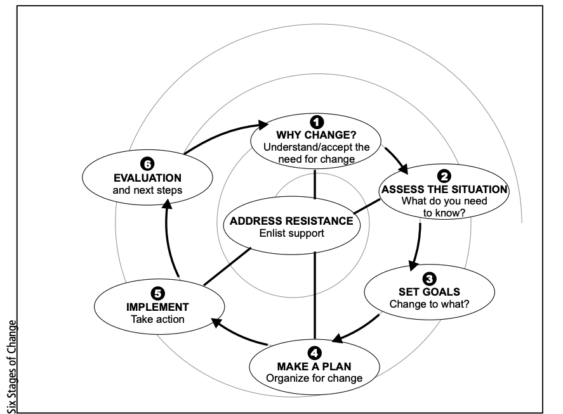
Six Stages of Change Model – British Columbia

(Affiliation of Multicultural Societies and Service Agencies of BC, 2001)

References

Aboriginal Health & Medical Research Council. (2015). Aboriginal communities improving Aboriginal health: An evidence review on the contribution of Aboriginal Community Controlled Health Services to improving Aboriginal health. Sydney: AH&MRC.

Affiliation of Multicultural Societies and Service Agencies of BC, 2001. Long-term Anti-racism Strategies: A Guide to Developing Effective Community Projects. pp.1-30.

Nichols, J. (2020). Addressing Racial Injustice in Long-Term Care. Caring For The Ages, 21(7), 4-5. https://doi.org/10.1016/j.carage.2020.09.011
Ontario Centres for Learning, Research and Innovation in Long-Term Care. (2017). Supporting Cultural Diversity in Long-Term Care Needs Assessment and Work Plan for 2017-18 (pp. 1-57). Retrieved from https://clri-ltc.ca/resource/diversity-needs-assessment/.

Pearson, O., Schwartzkopff, K., Dawson, A., Hagger, C., Karagi, A., & Davy, C. et al. (2020). Aboriginal community controlled health organisations address health equity through action on the social determinants of health of Aboriginal and Torres Strait Islander peoples in Australia. BMC Public Health, 20(1). https://doi.org/10.1186/s12889-020-09943-4

Panaretto, K., Wenitong, M., Button, S., & Ring, I. (2014). Aboriginal community controlled health services: leading the way in primary care. Medical Journal Of Australia, 200(11), 649-652. https://doi.org/10.5694/mja13.00005

